RDS TASK
Task 1: Create MariaDB database on EC2
We’ll use:
Setting | Value
Region | Your preferred AWS Region
EC2 name | MariaDB-EC2-Server
OS | Amazon Linux 2023
Instance type | t3.micro
Security group | MariaDB-EC2-SG
Database port | 3306
Database name | companydb
Step 1: Launch the EC2 instance
- Sign in to the AWS Management Console.
- Open EC2.
- Select Instances.
- Click Launch instances.
Configure:
Name
MariaDB-EC2-Server
AMI
Select:
Amazon Linux 2023 AMI
Instance type
Select:
t3.micro
Use a Free Tier-eligible type if your account offers one.
Key pair
Select an existing key pair or create one:
MariaDB-Key
Download and safely store the .pem file.
Step 2: Configure networking
Under Network settings, click Edit.
Use:
Setting | Selection
VPC | Default VPC or your lab VPC
Subnet | Public subnet
Auto-assign public IP | Enable
Security group | Create security group
Security group name | MariaDB-EC2-SG
Add this inbound rule:
Type | Port | Source
SSH | 22 | My IP
Do not open MariaDB port 3306 to 0.0.0.0/0. MariaDB will initially be accessed locally on the EC2 instance.
Keep the default outbound rule:
All traffic → 0.0.0.0/0
Click Launch instance.
AWS security groups operate as virtual firewalls for EC2 instances. AWS EC2 security-group documentation
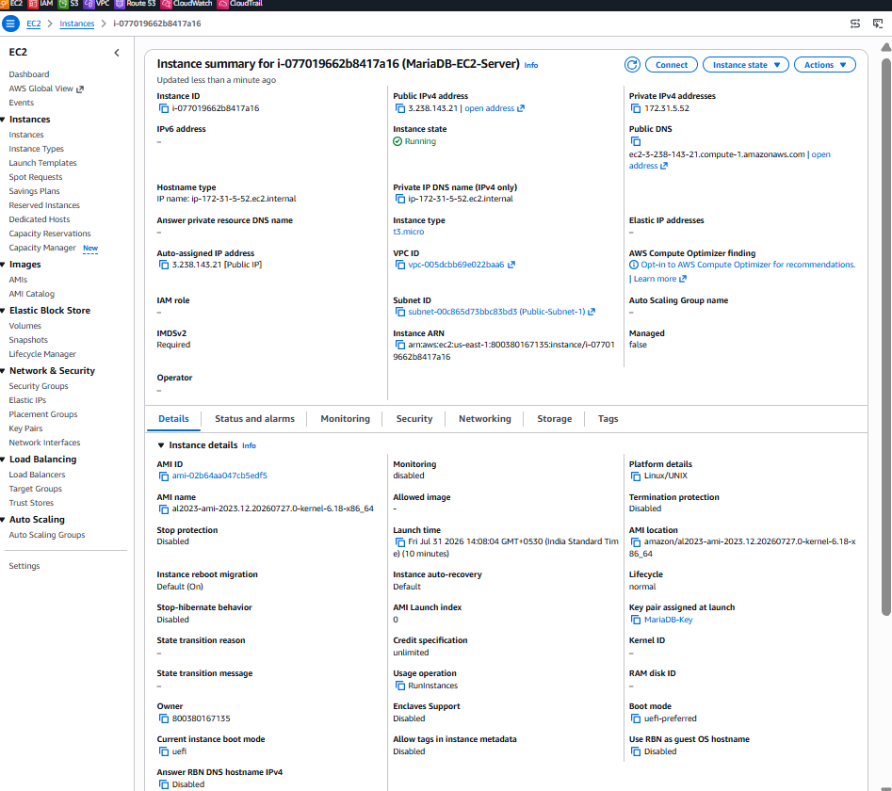
Step 3: Connect to the EC2 instance
Wait until:
Instance state: Running
Status checks: 2/2 checks passed
Select the instance and click:
Connect → EC2 Instance Connect → Connect
Alternatively, connect from Git Bash:
ssh -i MariaDB-Key.pem ec2-user@EC2-PUBLIC-IP
Replace EC2-PUBLIC-IP with the instance’s public IPv4 address.
Amazon Linux uses ec2-user as the default SSH username.
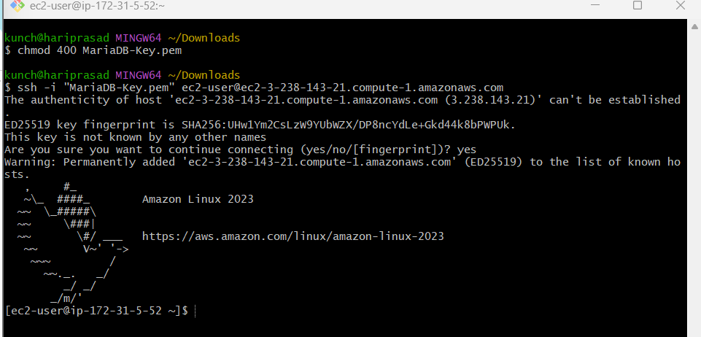
Step 4: Update installed packages
Run:
sudo dnf update -y
Check the operating system:
cat /etc/os-release
You should see Amazon Linux 2023 information.
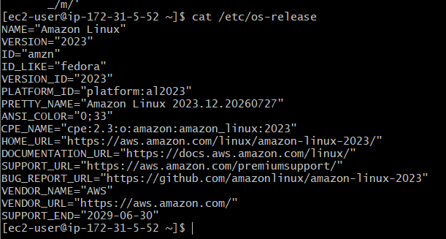
Step 5: Install MariaDB server
Run:
sudo dnf install mariadb105-server -y
Amazon Linux 2023 provides MariaDB 10.5 through the mariadb105-server package. AWS Amazon Linux documentation
Confirm installation:
mariadb --version
Expected output will resemble:
mariadb Ver 15.1 Distrib 10.5.x-MariaDB
The exact patch version may be different.
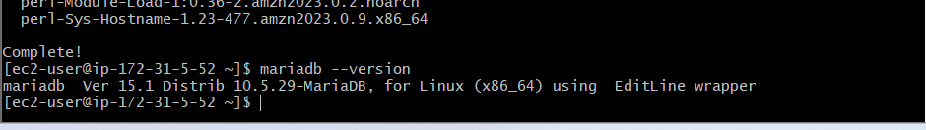
Step 6: Start MariaDB
Run:
sudo systemctl start mariadb
Enable MariaDB to start automatically after an EC2 reboot:
sudo systemctl enable mariadb
Verify the service:
sudo systemctl status mariadb
Expected result:
Active: active (running)
Press q to exit the status screen.
You can also verify it with:
sudo systemctl is-active mariadb
Expected output:
Active
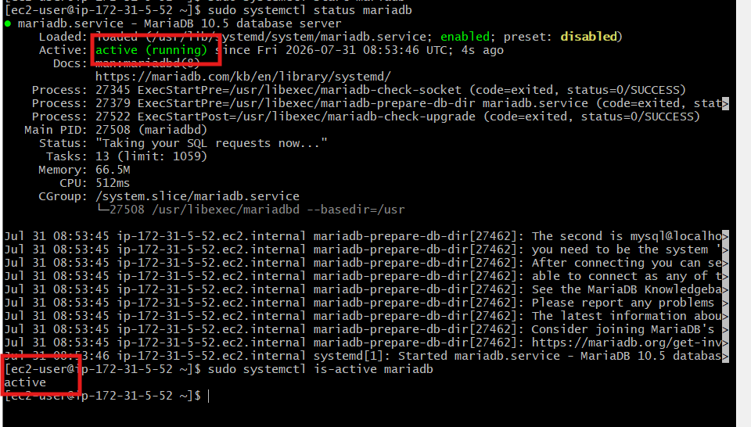
Step 7: Secure the MariaDB installation
Run:
sudo mariadb-secure-installation
Depending on the installed version, answer approximately as follows:
Enter current password for root: Press Enter

Switch to unix_socket authentication: Y
Change the root password: Y
New password: Enter a strong password
Remove anonymous users: Y
Disallow root login remotely: Y
Remove test database: Y
Reload privilege tables: Y
Store the password securely. Do not paste the real password into screenshots or documents.
If MariaDB reports that root is already protected using Unix socket authentication, that is acceptable for this lab.
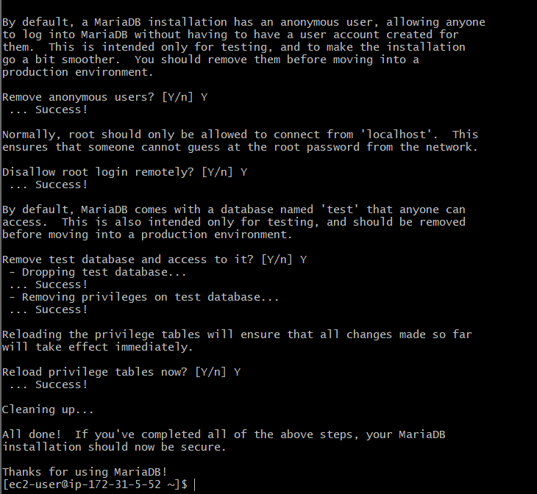
Step 8: Log in to MariaDB
Use:
sudo mariadb
You should get a prompt like:
MariaDB [(none)]>
Check the database version:
SELECT VERSION();
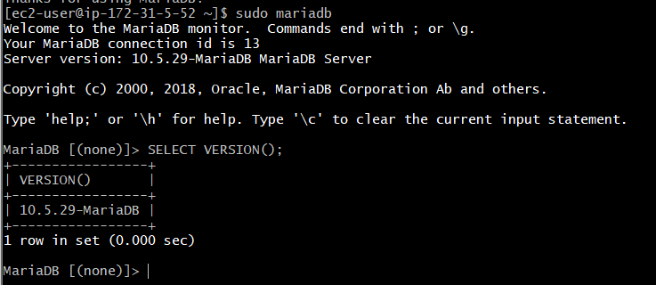
Step 9: Create the database
At the MariaDB prompt, run:
CREATE DATABASE companydb;
Verify it:
SHOW DATABASES;
Expected databases include:
companydb
information_schema
mysql
performance_schema
sys
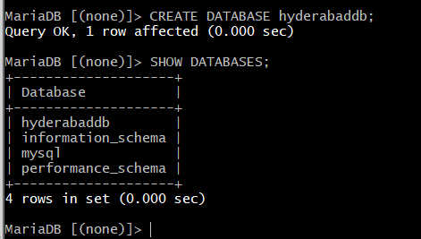
Step 10: Create a database user
Run:
CREATE USER 'dbadmin'@'localhost' IDENTIFIED BY 'YourStrongPassword@123';
Grant access only to companydb:
GRANT ALL PRIVILEGES ON companydb.* TO 'dbadmin'@'localhost';
Reload privileges:
FLUSH PRIVILEGES;
Verify the user:
SELECT User, Host FROM mysql.user;
Replace the example password with your own strong password.
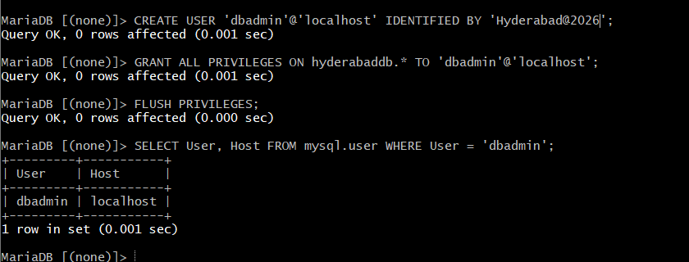
Step 11: Test the new user
Exit MariaDB:
EXIT;
Log in using the new user:
mariadb -u dbadmin -p
Enter the password, then run:
SHOW DATABASES;
Select the database:
USE companydb;
Check the currently selected database:
SELECT DATABASE();
Expected output:
companydb
Exit:
EXIT;
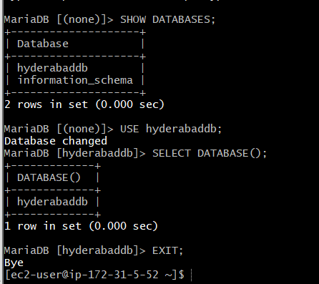
Task 1 verification
Run these commands:
sudo systemctl is-enabled mariadb
sudo systemctl is-active mariadb
sudo mariadb -e "SHOW DATABASES;"
Expected:
enabled
active
The database list must contain:
companydb
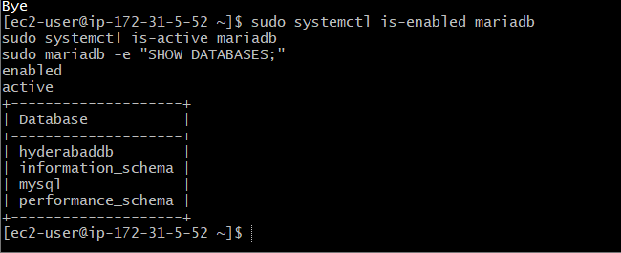

Task 2: Insert dummy data into MariaDB
Step 1: Select the database
If you are still at the MariaDB prompt, run:
USE companydb;
Expected:
Database changed
Check the selected database:
SELECT DATABASE();
Expected:
Companydb
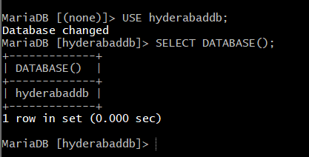
Step 2: Create an employees table
Run:
CREATE TABLE employees (
employee_id INT AUTO_INCREMENT PRIMARY KEY,
employee_name VARCHAR(100) NOT NULL,
department VARCHAR(50),
designation VARCHAR(100),
salary DECIMAL(10,2),
joining_date DATE
);
Expected:
Query OK, 0 rows affected
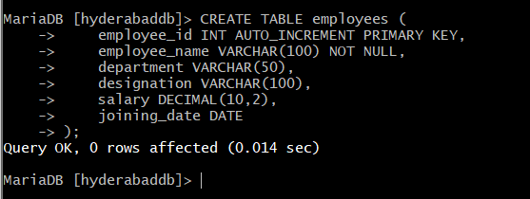
Step 3: Verify the table
SHOW TABLES;
Expected:
employees
Check its structure:
DESCRIBE employees;
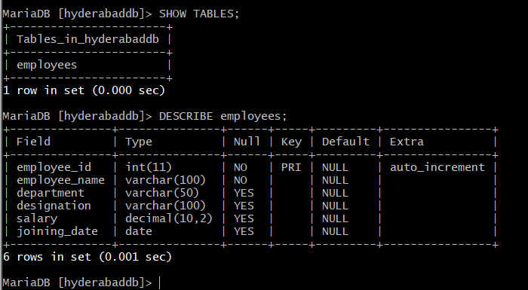
Step 4: Insert dummy data
Run:
INSERT INTO employees
(employee_name, department, designation, salary, joining_date)
VALUES
('Venu Gopal', 'DevOps', 'DevOps Engineer', 85000.00, '2021-08-10'),
('Rahul Kumar', 'Development', 'Java Developer', 75000.00, '2022-03-15'),
('Priya Sharma', 'Testing', 'QA Engineer', 65000.00, '2023-01-20'),
('Anil Reddy', 'Cloud', 'AWS Engineer', 80000.00, '2022-07-11'),
('Sneha Patel', 'Database', 'Database Administrator', 90000.00, '2020-11-05');
Expected:
Query OK, 5 rows affected
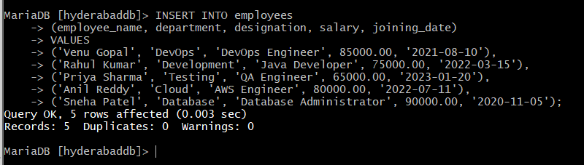
Step 5: Verify the dummy data
SELECT * FROM employees;
You should see five employee records.
Check the total number of records:
SELECT COUNT(*) AS total_employees FROM employees;
Expected:
total_employees
5
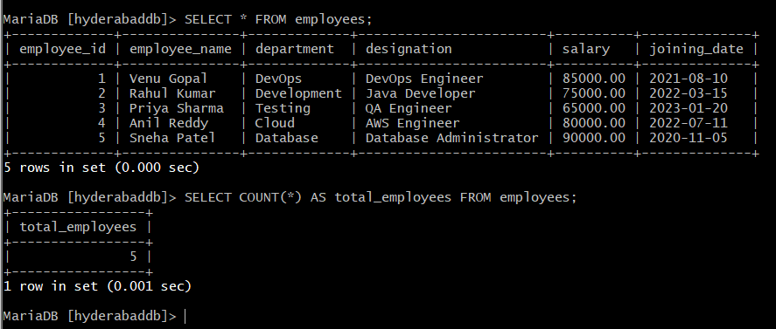
Step 6: Test the dbadmin user
Exit:
EXIT;
Log in as dbadmin:
mariadb -u dbadmin -p
Enter your database password and run:
USE companydb;
SELECT * FROM employees;
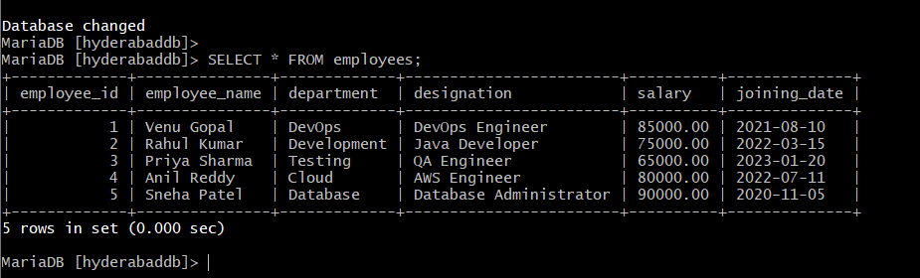

Task 3: Back up MariaDB data on EC2
We will take a logical SQL backup using mariadb-dump.
Step 1: Exit MariaDB
At the MariaDB prompt, run:
EXIT;
You should return to:
[ec2-user@ip-172-31-5-52 ~]$
Step 2: Create a backup directory
At the Linux prompt, run:
mkdir -p /home/ec2-user/db-backups
Verify:
ls -ld /home/ec2-user/db-backups
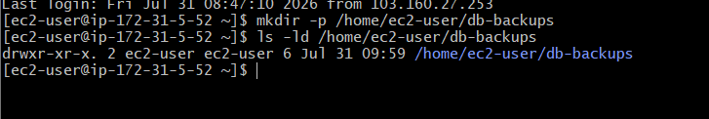
Step 3: Take the database backup
Run:
sudo mariadb-dump --single-transaction --routines --triggers hyderabaddb > /home/ec2-user/db-backups/hyderabaddb_backup.sql
What the options mean:
- --single-transaction: Creates a consistent backup without locking InnoDB tables for a long time.
- --routines: Includes stored procedures and functions.
- --triggers: Includes database triggers.
No output normally means the backup succeeded.
Step 4: Verify the backup file
ls -lh /home/ec2-user/db-backups/
You should see:
hyderabaddb_backup.sql
Check that the file is not empty:
test -s /home/ec2-user/db-backups/hyderabaddb_backup.sql && echo "Backup successful" || echo "Backup failed"
Expected:
Backup successful
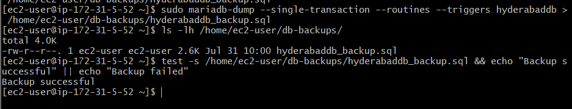
Step 5: Confirm that employee data exists in the backup
grep -n "INSERT INTO.*employees" /home/ec2-user/db-backups/hyderabaddb_backup.sql
You should see an INSERT INTO employees statement containing the five records.
Step 6: Generate a checksum
sha256sum /home/ec2-user/db-backups/hyderabaddb_backup.sql
This checksum helps verify later that the backup file was not changed or corrupted.
Task 3 is complete when:
Backup successful
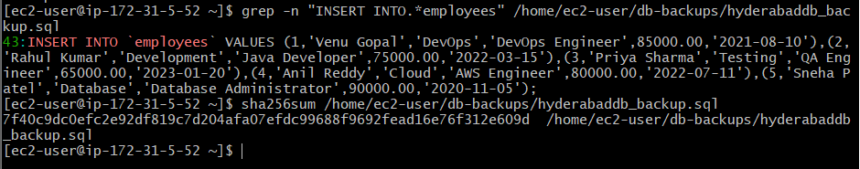
Task 4: Launch a MariaDB RDS instance
We will create a private RDS instance in the same default VPC as the EC2 server.
Step 1: Create the RDS security group
Open:
EC2 → Network & Security → Security Groups
Click Create security group.
Enter:
Setting | Value
Security group name | RDS-MariaDB-SG
Description | Allow MariaDB access from EC2
VPC | vpc-005dcbb69e022baa6
Add this inbound rule:
Type | Port | Source
MySQL/Aurora | 3306 | MariaDB-EC2-SG
For Source, select Custom, search for MariaDB-EC2-SG, and select that security group.
Do not use:
0.0.0.0/0
Keep the default outbound rule and click Create security group.
This means only EC2 instances attached to MariaDB-EC2-SG can connect to RDS on port 3306. AWS RDS security-group guidance
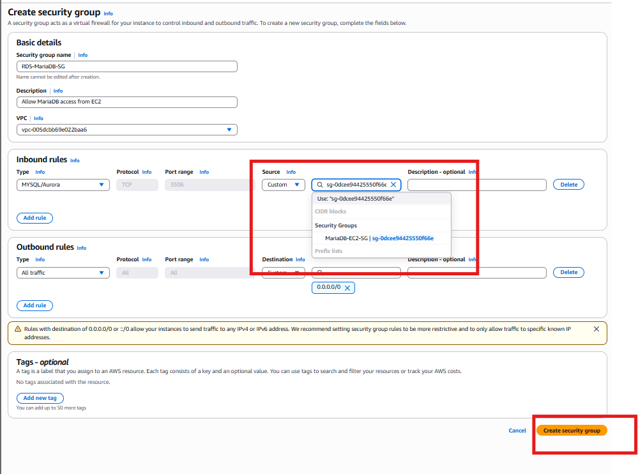
Step 2: Open Amazon RDS
- Search for RDS in the AWS Console.
- Confirm the Region is N. Virginia — us-east-1.
- Open Databases.
- Click Create database.
Step 3: Select database creation method
Choose:
Standard create
This displays all configuration options.
Step 4: Select the database engine
Under Engine options, choose:
MariaDB
For the engine version, choose an available supported MariaDB 10.6.x version. This is close to the EC2 source version, MariaDB 10.5.29, and appropriate for this migration lab.
Do not select MySQL here. MySQL RDS will be created separately in Task 7.
Step 5: Select the template
Choose:
Free tier
If Free tier is unavailable, select:
Dev/Test
Be aware that RDS can generate charges while running.
Step 6: Configure availability
For this MariaDB migration lab, select:
Single DB instance
We will configure Multi-AZ later during the MySQL RDS task.
Step 7: Configure database settings
Enter:
Setting | Value
DB instance identifier | mariadb-rds-instance
Master username | venuadmin
Credentials management | Self managed
Master password | Create a new strong password
Confirm password | Enter the same password
Do not reuse or share the password previously posted in chat. Store the new RDS password safely.
Step 8: Select the instance class
Use one of the available small burstable classes:
db.t3.micro
If that is unavailable or another Free Tier class is offered, use:
db.t4g.micro
Step 9: Configure storage
Use:
Setting | Value
Storage type | General Purpose SSD (gp3)
Allocated storage | 20 GiB
Storage encryption | Enabled
Storage autoscaling | Disable for this short lab
Step 10: Configure connectivity
Use:
Setting | Value
Compute resource | Don’t connect to an EC2 compute resource
Network type | IPv4
VPC | Default VPC – vpc-005dcbb69e022baa6
DB subnet group | default
Public access | No
VPC security group | Choose existing
Existing security group | RDS-MariaDB-SG
Availability Zone | No preference
Database port | 3306
Remove the default security group if the console permits, leaving only:
RDS-MariaDB-SG
The EC2 instance and RDS instance must use the same VPC for this private connection. AWS automatic EC2–RDS connectivity requirements
Step 11: Additional configuration
Expand Additional configuration and set:
Setting | Value
Initial database name | hyderabaddb
DB parameter group | Default
Option group | Default
Automated backups | Enabled
Backup retention | 1 day
Backup window | No preference
Performance Insights | Disable for this lab
Enhanced Monitoring | Disable
Log exports | Leave unchecked
Auto minor version upgrade | Enable
Maintenance window | No preference
Deletion protection | Disable for this lab
The initial database name must not contain spaces or hyphens:
hyderabaddb
Step 12: Review and create
Review the estimated monthly cost and click:
Create database
Wait until the status changes:
Creating → Backing-up → Available
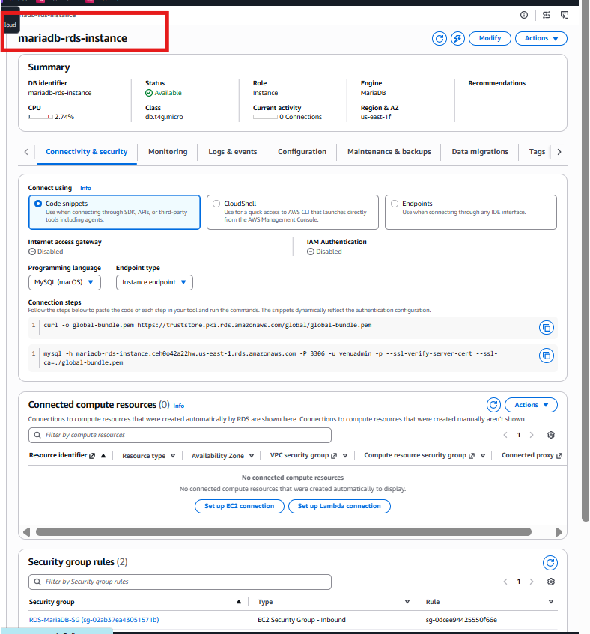

Task 5: Migrate MariaDB from EC2 to RDS
Return to your EC2 terminal.
Step 1: Set the RDS endpoint
Copy the endpoint from:
RDS → mariadb-rds-instance → Connectivity & security
Then run on EC2:
RDS_ENDPOINT="paste-your-rds-endpoint-here"
Example format:
RDS_ENDPOINT="mariadb-rds-instance.xxxxxxxxxxxx.us-east-1.rds.amazonaws.com"
Do not include:
- https://
- Port 3306
- Spaces
Verify:
echo "$RDS_ENDPOINT"
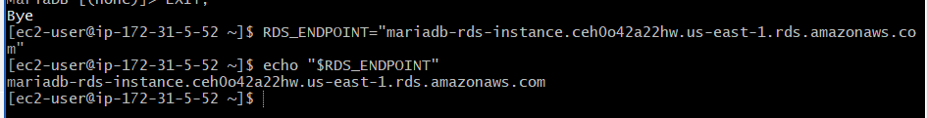
Step 2: Test DNS and network access
getent hosts "$RDS_ENDPOINT"
It should return a private IP address.
Test port 3306:
timeout 5 bash -c "</dev/tcp/$RDS_ENDPOINT/3306" && echo "Port 3306 reachable" || echo "Port 3306 blocked"
Expected:
Port 3306 reachable
If it says blocked, we will check RDS-MariaDB-SG.
Step 3: Download the AWS RDS certificate
curl -o global-bundle.pem https://truststore.pki.rds.amazonaws.com/global/global-bundle.pem
Verify:
ls -lh global-bundle.pem
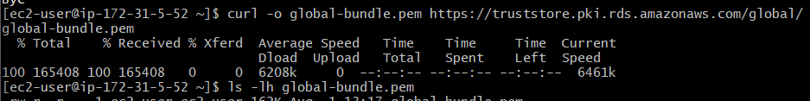
Step 4: Connect to MariaDB RDS
mariadb \
-h "$RDS_ENDPOINT" \
-P 3306 \
-u venuadmin \
-p \
--ssl-ca=global-bundle.pem \
--ssl-verify-server-cert
Enter the RDS master password when prompted.
At the RDS MariaDB prompt, verify:
SELECT VERSION();
SHOW DATABASES;
Confirm that this database exists:
hyderabaddb
Exit:
EXIT;
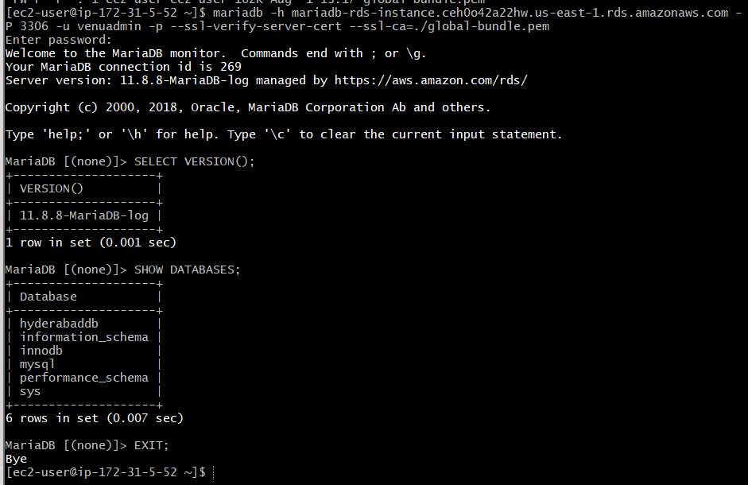
Step 5: Import the EC2 backup into RDS
Run at the Linux prompt:
mariadb \
-h "$RDS_ENDPOINT" \
-P 3306 \
-u venuadmin \
-p \
--ssl-ca=global-bundle.pem \
--ssl-verify-server-cert \
hyderabaddb < /home/ec2-user/db-backups/hyderabaddb_backup.sql
Enter the RDS password. No output generally means the migration succeeded.
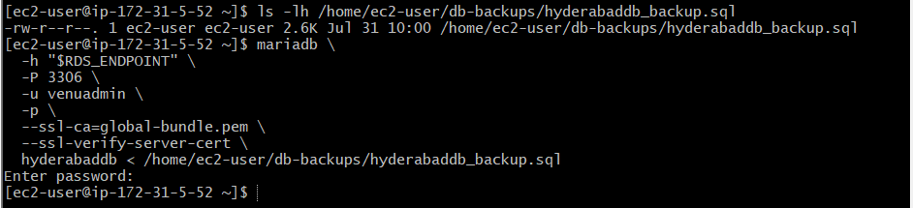
Step 6: Verify the migrated data
Connect again:
mariadb \
-h "$RDS_ENDPOINT" \
-P 3306 \
-u venuadmin \
-p \
--ssl-ca=global-bundle.pem \
--ssl-verify-server-cert
Run:
USE hyderabaddb;
SHOW TABLES;
SELECT * FROM employees;
SELECT COUNT(*) AS migrated_rows FROM employees;
Expected:
employees
migrated_rows: 5
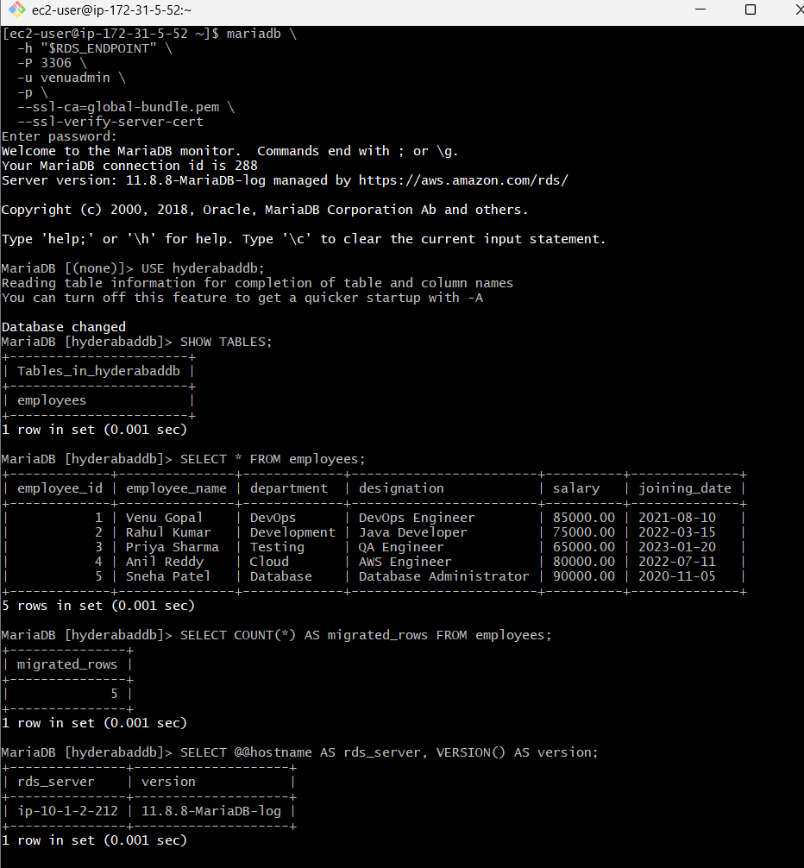
Task 6: Install MySQL on EC2
We’ll use a new EC2 instance. Do not install MySQL on MariaDB-EC2-Server because MariaDB already uses port 3306 and the packages can conflict.
Step 1: Launch a separate EC2 instance
Open:
EC2 → Instances → Launch instances
Configure:
Setting | Value
Name | MySQL-EC2-Server
AMI | Ubuntu Server 24.04 LTS, 64-bit x86
Instance type | t3.micro
Key pair | Existing MariaDB-Key
VPC | Default VPC
Subnet | Public-Subnet-1
Auto-assign public IP | Enable
We’re using Ubuntu because MySQL Server can be installed directly and cleanly through Ubuntu’s package manager.
Security group
Create:
MySQL-EC2-SG
Add:
Type | Port | Source
SSH | 22 | My IP
Do not open port 3306 publicly.
Keep default outbound access:
All traffic → 0.0.0.0/0
Storage
Use:
8 GiB gp3
Encryption: Enabled
Click Launch instance and wait for:
Running
Status checks: 2/2 passed
Important: the Ubuntu SSH username will be:
ubuntu
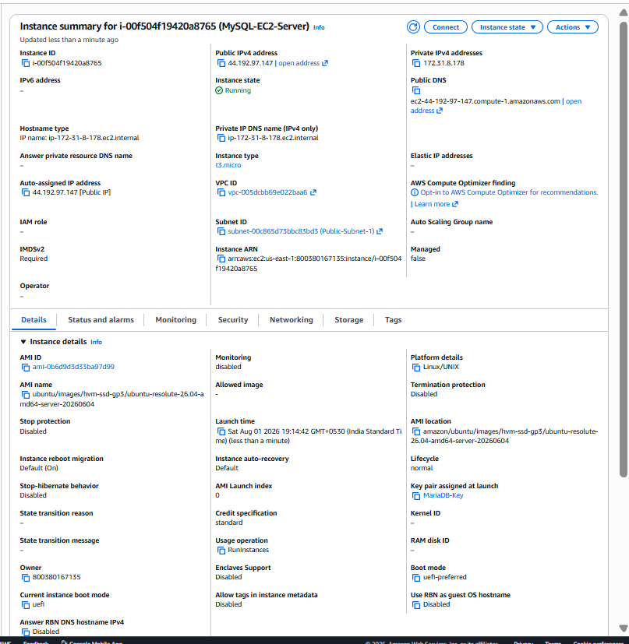

Connect and install MySQL
Step 1: Copy the public DNS
Open:
EC2 → Instances → MySQL-EC2-Server
Copy its current Public IPv4 DNS, which looks like:
ec2-x-x-x-x.compute-1.amazonaws.com
Step 2: Connect from Git Bash
On your Windows computer, open Git Bash in the Downloads folder:
cd ~/Downloads
Connect using the same key, but use the Ubuntu username:
ssh -i "MariaDB-Key.pem" ubuntu@MYSQL-EC2-PUBLIC-DNS
Replace MYSQL-EC2-PUBLIC-DNS with the actual DNS name.
Example format only:
ssh -i "MariaDB-Key.pem" ubuntu@ec2-x-x-x-x.compute-1.amazonaws.com
A successful connection displays:
ubuntu@ip-172-31-x-x:~$
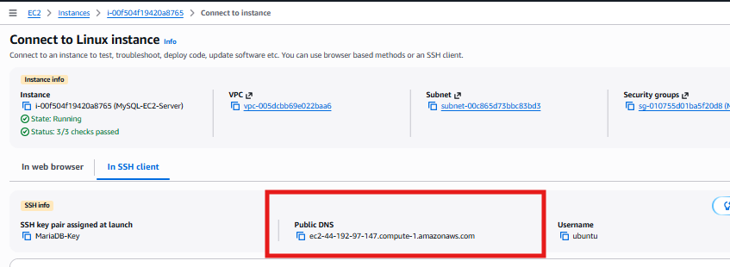
Step 3: Update Ubuntu packages
Run inside the EC2 instance:
sudo apt update
Then:
sudo apt upgrade -y
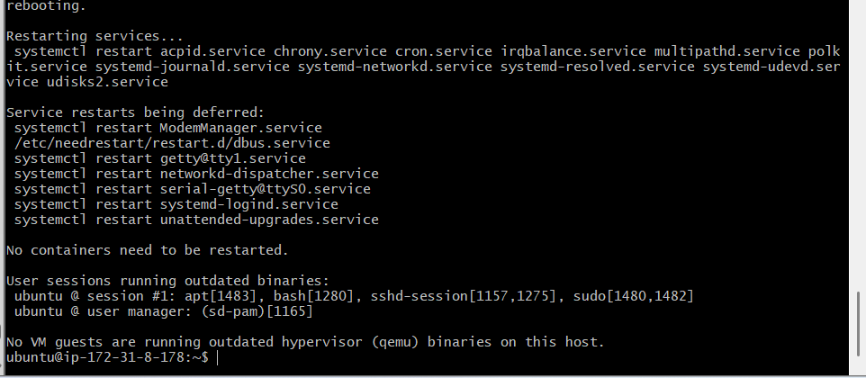
Step 4: Check the available MySQL version
apt-cache policy mysql-server
Look for:
Candidate: ...
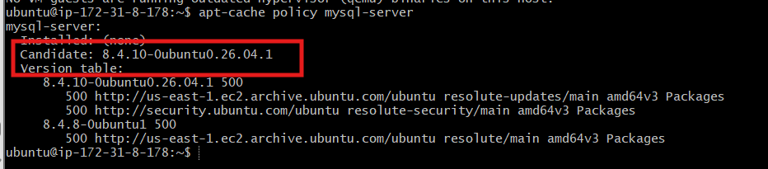
Step 5: Install MySQL Server
sudo apt install mysql-server -y
Step 6: Check the MySQL version
mysql –version
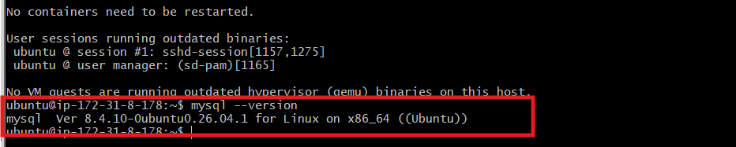
Step 7: Verify the service
sudo systemctl status mysql
Expected:
Active: active (running)
Press q to exit.
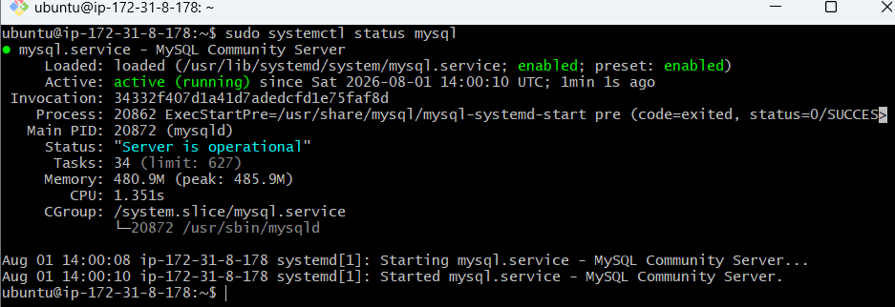

Ensure it starts automatically:
sudo systemctl enable mysql
Verify:
sudo systemctl is-active mysql
sudo systemctl is-enabled mysql
Expected:
active
enabled
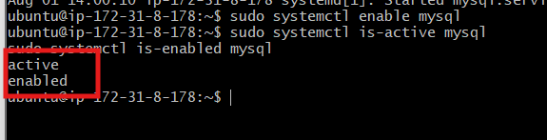

Secure the MySQL Installation
Step 1: Run the security configuration
At the Ubuntu prompt, run:
sudo mysql_secure_installation
Answer the prompts as follows.
Validate password component
If asked:
Would you like to setup VALIDATE PASSWORD component?
Enter:
Y
Choose:
1
for MEDIUM password policy.
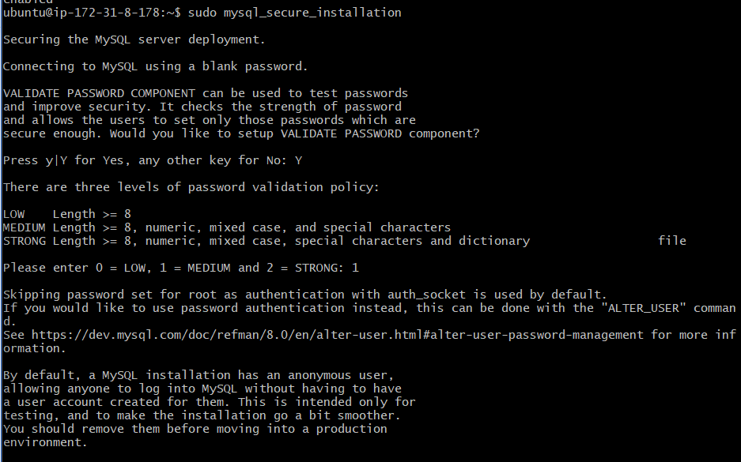
Root password
If asked to enter the current root password, press Enter, because Ubuntu initially uses socket authentication.
If asked to set or change the root password, use a strong temporary lab password without sharing it in chat.
Remaining questions
Answer:
Remove anonymous users? Y
Disallow root login remotely? Y
Remove test database and access to it? Y
Reload privilege tables now? Y
Expected final message:
All done!
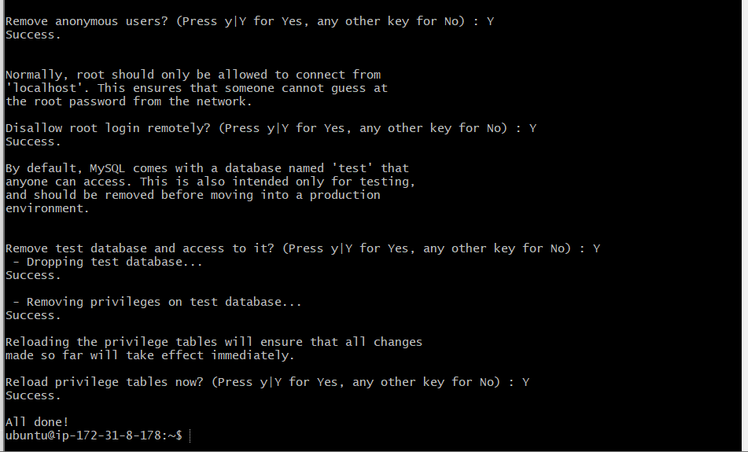
Verify MySQL Root Access
Step 2: Test the MySQL root login
Run:
sudo mysql
Expected prompt:
mysql>
Verify:
SELECT VERSION();
You should see:
8.4.10
Check databases:
SHOW DATABASES;
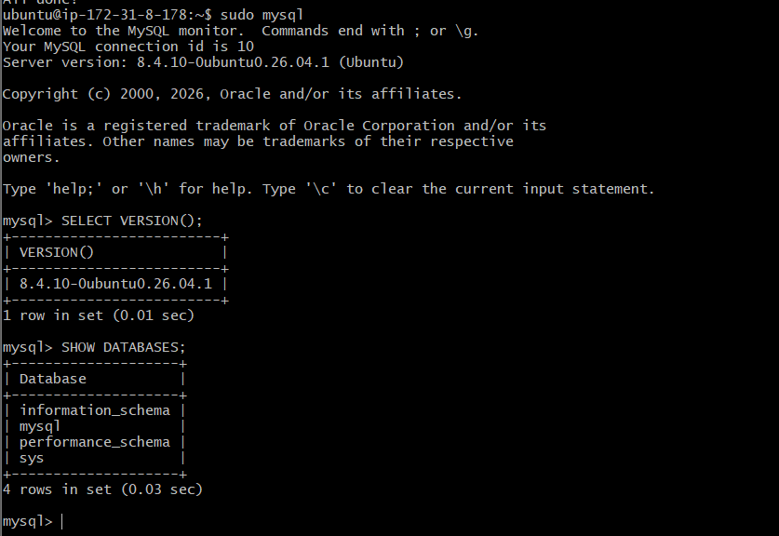

Create a MySQL database
At the Ubuntu terminal, enter MySQL:
sudo mysql
At the mysql> prompt, create the database:
CREATE DATABASE mysqldb;
Select it:
USE mysqldb;
Verify:
SELECT DATABASE();
Expected:
Mysqldb
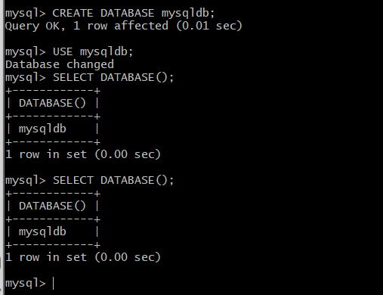
Create a table
CREATE TABLE customers (
customer_id INT AUTO_INCREMENT PRIMARY KEY,
customer_name VARCHAR(100) NOT NULL,
city VARCHAR(50),
email VARCHAR(100),
created_date DATE
);
Verify:
SHOW TABLES;
Expected:
Customers
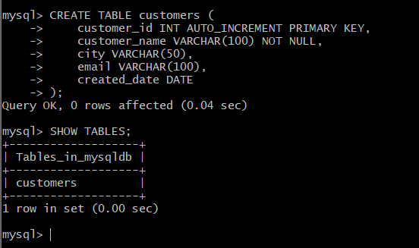
Insert dummy data
INSERT INTO customers
(customer_name, city, email, created_date)
VALUES
('Venu Gopal', 'Hyderabad', 'venu@example.com', '2026-01-10'),
('Rahul Kumar', 'Bengaluru', 'rahul@example.com', '2026-02-15'),
('Priya Sharma', 'Chennai', 'priya@example.com', '2026-03-20'),
('Anil Reddy', 'Guntur', 'anil@example.com', '2026-04-11'),
('Sneha Patel', 'Mumbai', 'sneha@example.com', '2026-05-05');
Verify:
SELECT * FROM customers;
Count the rows:
SELECT COUNT(*) AS total_customers FROM customers;
Expected:
total_customers: 5
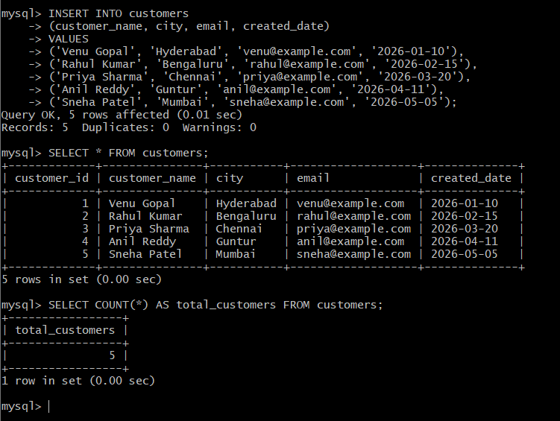
Step 11: Create a database user
Use your own strong password:
CREATE USER 'appuser'@'localhost' IDENTIFIED BY 'YourStrongPassword#2026';
Grant access:
GRANT ALL PRIVILEGES ON mysqldb.* TO 'appuser'@'localhost';
FLUSH PRIVILEGES;
Verify:
SHOW GRANTS FOR 'appuser'@'localhost';
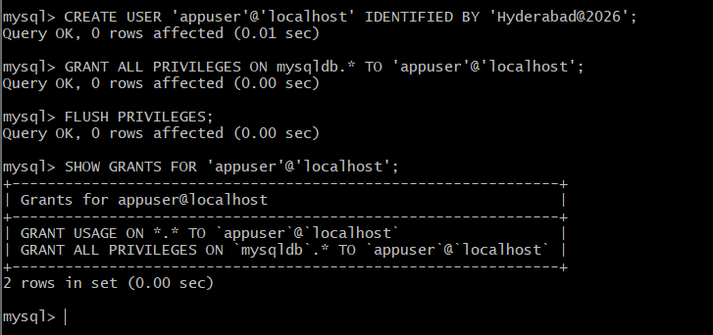
Task 7: Launch a MySQL RDS instance
We’ll create a separate MySQL RDS instance and allow access only from MySQL-EC2-Server.
Step 1: Create the RDS security group
Open:
EC2 → Network & Security → Security Groups
Click Create security group.
Configure:
Setting | Value
Security group name | RDS-MySQL-SG
Description | Allow MySQL EC2 to connect to MySQL RDS
VPC | vpc-005dcbb69e022baa6
Add this inbound rule:
Type | Port | Source
MySQL/Aurora | 3306 | MySQL-EC2-SG
For Source:
- Select Custom.
- Search for MySQL-EC2-SG.
- Select that security group.
Do not use:
0.0.0.0/0
Keep the default outbound rule:
All traffic → 0.0.0.0/0
Click Create security group.
This creates the secure network path:
MySQL-EC2-SG → TCP 3306 → RDS-MySQL-SG
After creating RDS-MySQL-SG, we’ll configure the MySQL RDS instance.
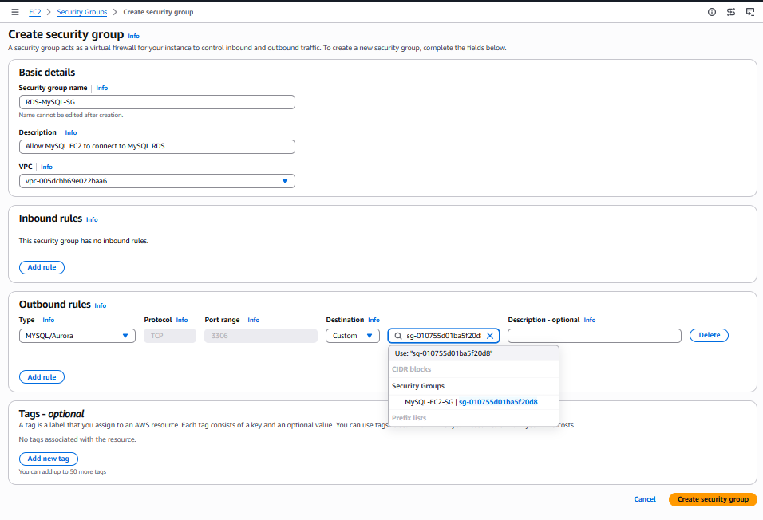
The security group was created, but the required inbound rule is missing:
Inbound rules count: 0
Add the MySQL rule now.
Add the inbound rule
- Click Edit inbound rules.
- Click Add rule.
- Configure:
Setting | Value
Type | MySQL/Aurora
Protocol | TCP
Port | 3306
Source type | Custom
Source | MySQL-EC2-SG
In the Source field, search for:
MySQL-EC2-SG
Select its security-group ID from the dropdown.
- Click Save rules.
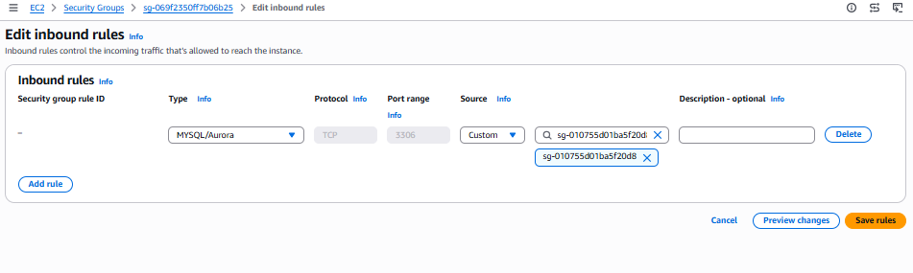
After saving, confirm:
Inbound rules count: 1
The rule should look like:
MySQL/Aurora | TCP | 3306 | sg-xxxxxx (MySQL-EC2-SG)
Do not enter 0.0.0.0/0.

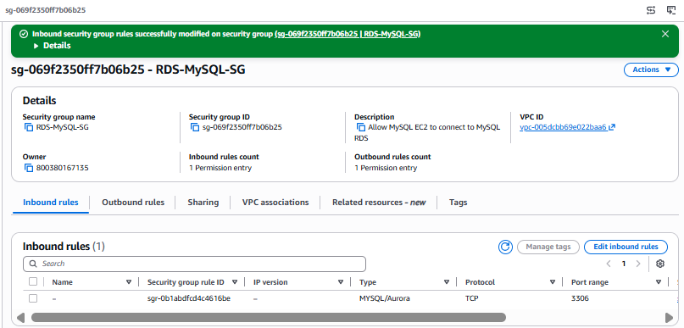

Task 7 – Step 2: Create MySQL RDS
Open:
Aurora and RDS → Databases
Click the dropdown arrow beside Create database and select:
Full configuration
Configure the following.
Engine and template
Setting | Value
Engine type | MySQL
Creation method | Full configuration
Template | Free tier
Engine version | MySQL 8.4.10, if offered
Using MySQL 8.4 matches the MySQL 8.4.10 server on EC2.
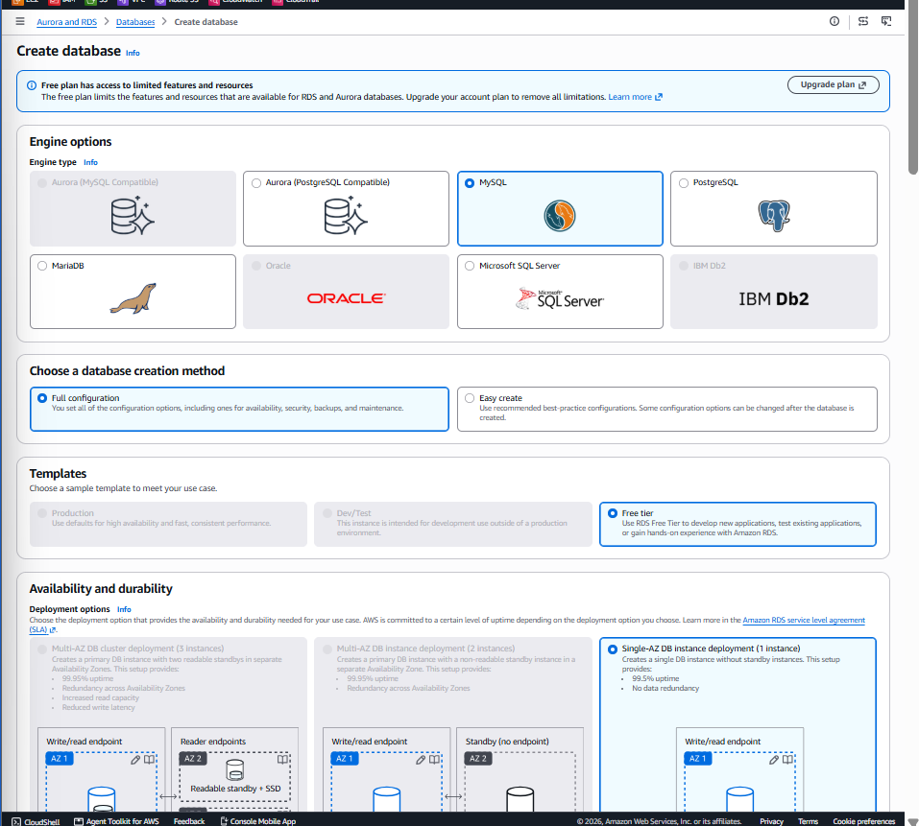
Settings
Setting | Value
DB identifier | mysql-rds-instance
Master username | venuadmin
Credentials management | Self managed
Authentication | Password authentication
Create a new strong password and do not use /, ', ", or @.
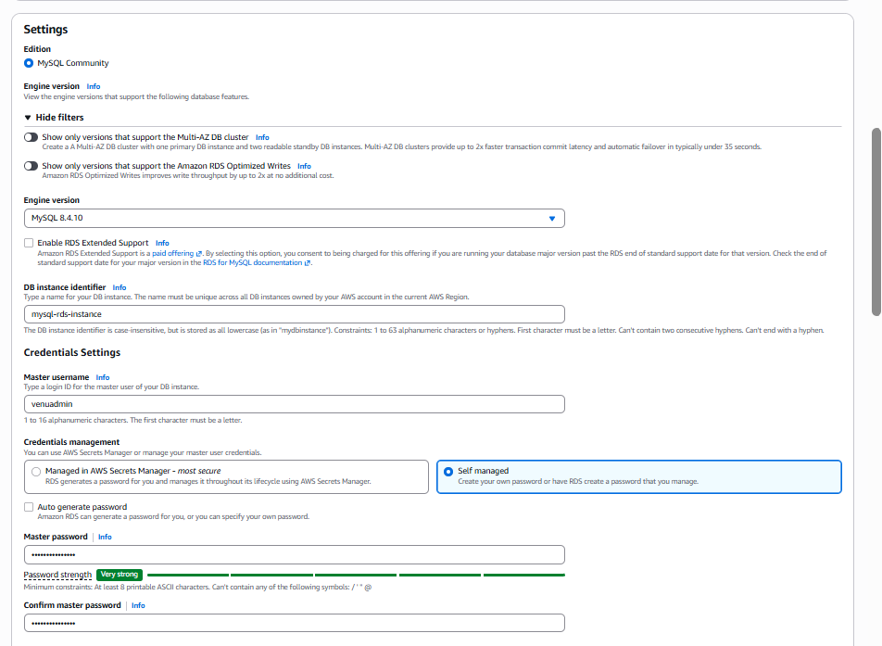
Instance and storage
Setting | Value
Instance class | db.t4g.micro
Storage | 20 GiB gp2
Storage autoscaling | Disabled
Encryption | Enabled using aws/rds
Availability
For Task 7, select:
Do not create a standby instance
This creates Single-AZ first. In Task 8, we’ll modify it and configure Multi-AZ so you can see the actual conversion process.
Connectivity
Setting | Value
Compute resource | Don’t connect to EC2
Network | IPv4
VPC | vpc-005dcbb69e022baa6
DB subnet group | default
Public access | No
Security group | RDS-MySQL-SG
Availability Zone | No preference
Port | 3306
RDS Proxy | Disabled
Remove the default security group if possible and retain only RDS-MySQL-SG.
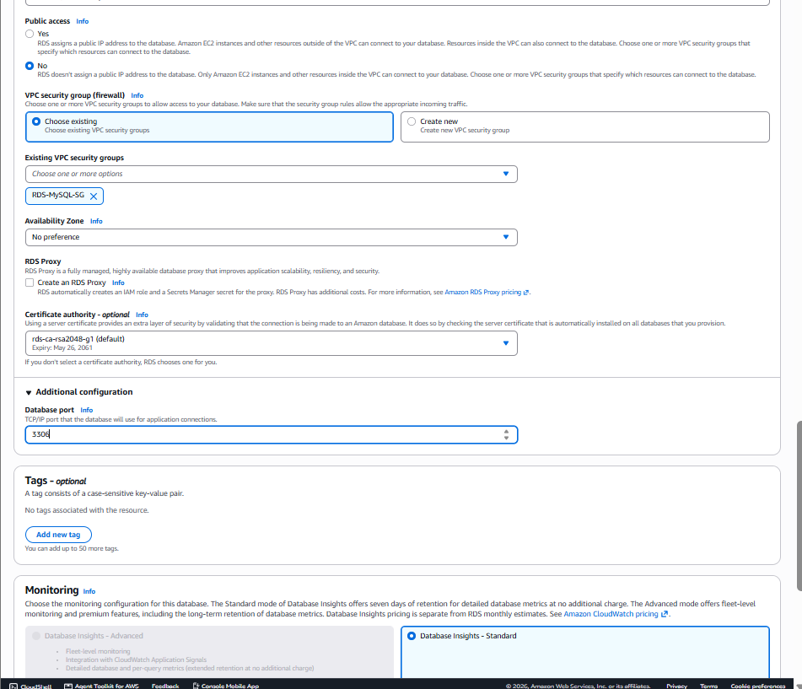

Monitoring
Select:
Database Insights – Standard
Enhanced Monitoring: Disabled
Log exports: Unchecked
Additional configuration
Setting | Value
Initial database name | mysqldb
Automated backups | Enabled
Retention | 1 day
Backup window | No preference
Auto minor version upgrade | Enabled
Cross-Region backup replication | Disabled
Deletion protection | Disabled
Optional tag:
Key: Name
Value: MySQL-RDS-Lab
Review the cost estimate and click Create database. Since your MariaDB RDS instance is also running, monitor your Free plan allowance/credits and delete lab resources after completing all tasks.
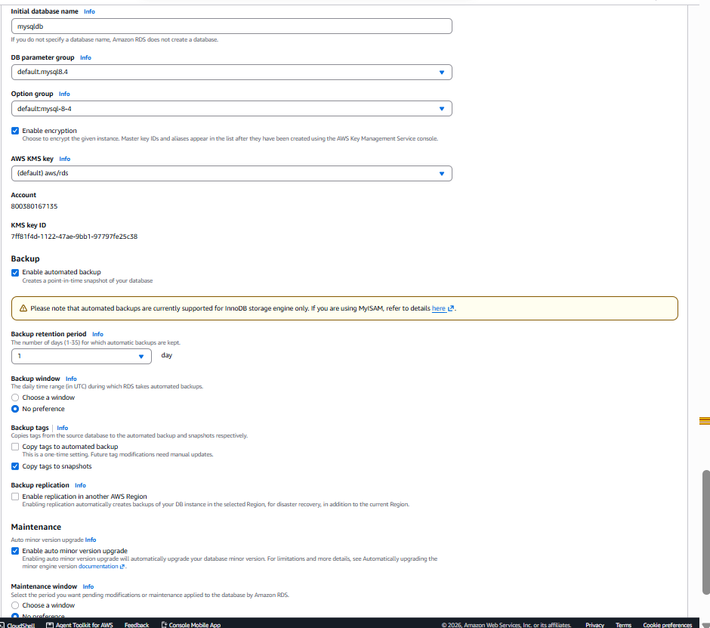
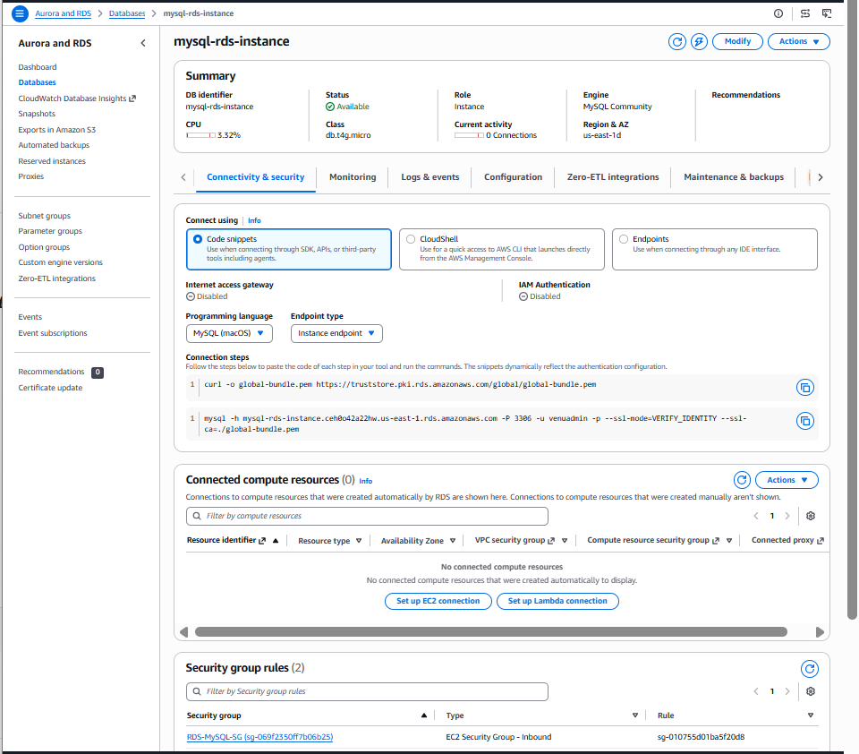

Task 8: Configure Multi-AZ for MySQL RDS
First wait until:
mysql-rds-instance → Status: Available
Multi-AZ creates a second standby DB instance in another Availability Zone, so it increases RDS cost. It is generally outside Free Tier allowances.
Step 1: Convert to Multi-AZ
Open:
Aurora and RDS → Databases
Select:
mysql-rds-instance
Choose:
Actions → Convert to Multi-AZ deployment
If that action is not available, use:
Modify → Availability & durability
Then select:
Multi-AZ DB instance deployment
or:
Create a standby instance
Do not choose Multi-AZ DB cluster deployment (3 instances). We need one primary and one non-readable standby.
Step 2: Apply the modification
On the confirmation page, select:
Apply immediately
Review the cost impact and click:
Convert to Multi-AZ
or:
Modify DB instance
AWS will:
- Take a snapshot of the primary volume.
- Create a standby in another Availability Zone.
- Configure synchronous replication.
- Maintain the same RDS endpoint.
AWS states that this normally avoids an outage, although performance may be temporarily affected during the conversion. AWS Multi-AZ conversion documentation
Step 3: Monitor the conversion
The status may change through:
Available → Modifying → Available
The conversion may take several minutes.
Step 4: Verify Multi-AZ
After it returns to Available, open:
mysql-rds-instance → Configuration
Confirm:
Multi-AZ: Yes
Under Connectivity & security, you may also see a secondary Availability Zone.
Multi-AZ is for high availability and automatic failover. The standby is not directly accessible and cannot be used for read queries.

NOTE:
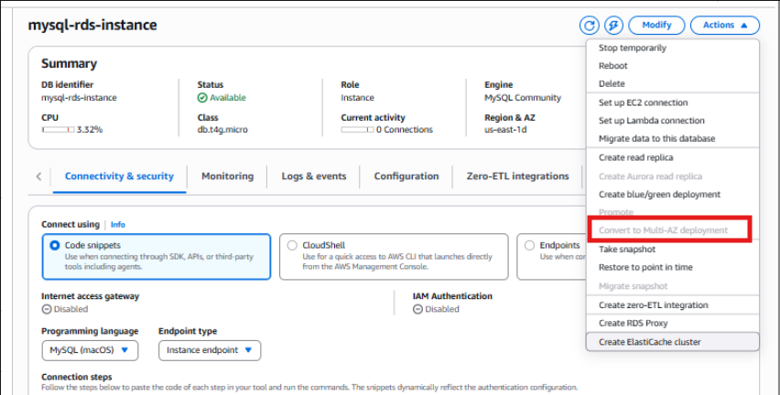
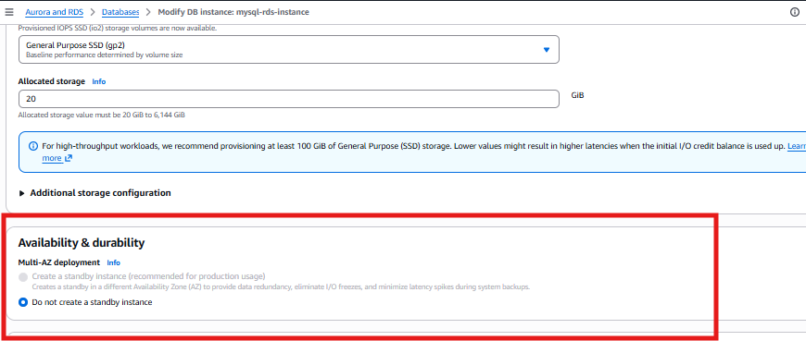
The screenshots confirm that Multi-AZ is disabled by your current AWS Free plan:
- Convert to Multi-AZ deployment is greyed out.
- Create a standby instance is greyed out.
- Only Do not create a standby instance is selectable.
This is an account-plan limitation, not a configuration error. db.t4g.micro, MySQL 8.4, the default subnet group, and the six Availability Zones are otherwise suitable.
options
Option 1: Skip Multi-AZ for this lab — recommended
Document Task 8 as:
Multi-AZ configuration could not be enabled because the AWS Free plan
restricts the standby-instance feature. The MySQL RDS instance remains
Single-AZ. Screenshots were captured as evidence.
This avoids extra charges.
Option 2: Upgrade the AWS plan
Use the Upgrade plan link displayed on the RDS creation page. After upgrading:
RDS → mysql-rds-instance → Modify
→ Availability & durability
→ Create a standby instance
→ Continue → Apply immediately
Multi-AZ creates another RDS instance and normally increases compute and storage costs.

To complete Task 8 practically, you need one of these:
- Upgrade this AWS account to a paid plan, then modify the instance to Create a standby instance.
- Use another AWS account or company sandbox where Multi-AZ is permitted.
Multi-AZ will create a second RDS instance and may approximately double database compute/storage charges while enabled. If you do not want to upgrade, mark Task 8 as:
Blocked: Multi-AZ is unavailable under the current AWS Free plan.
Verified through both Actions and Modify options.

Task 9: Back up MySQL and restore it to RDS
We’ll back up mysqldb from MySQL-EC2-Server, then restore it into mysql-rds-instance.
Step 1: Connect to MySQL EC2
From Git Bash:
cd ~/Downloads
ssh -i "MariaDB-Key.pem" ubuntu@MYSQL-EC2-PUBLIC-DNS
Use the current Public IPv4 DNS of MySQL-EC2-Server.
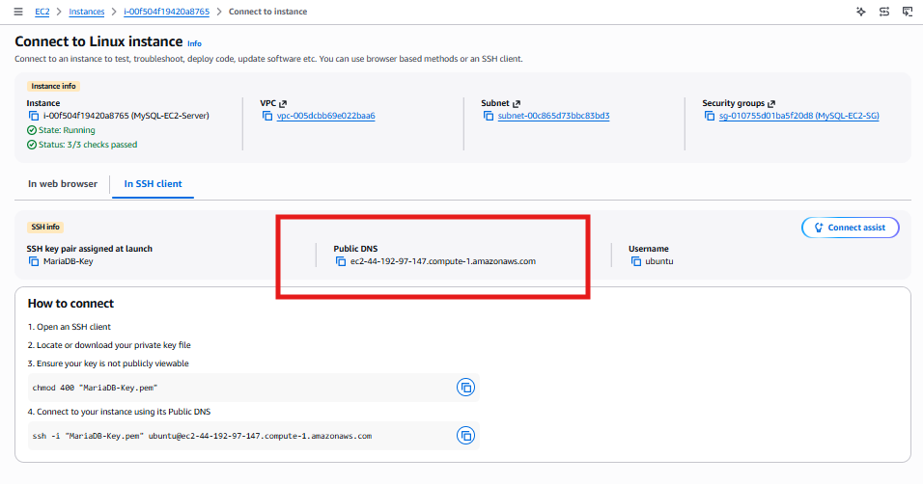
Step 2: Create a backup directory
At the Ubuntu prompt:
mkdir -p /home/ubuntu/db-backups
Step 3: Take the MySQL backup
sudo mysqldump \
--single-transaction \
--routines \
--triggers \
--no-tablespaces \
--set-gtid-purged=OFF \
mysqldb > /home/ubuntu/db-backups/mysqldb_backup.sql
No output normally means the backup succeeded.
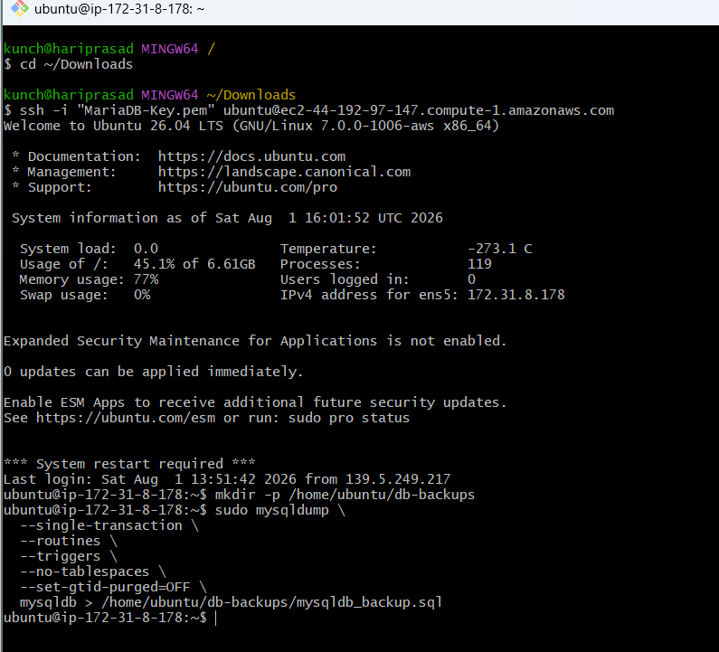
Options:
- --single-transaction: Creates a consistent InnoDB backup.
- --routines: Includes functions and procedures.
- --triggers: Includes triggers.
- --no-tablespaces: Avoids RDS tablespace privilege errors.
- --set-gtid-purged=OFF: Avoids GTID permission problems during RDS restoration.
Step 4: Verify the backup
ls -lh /home/ubuntu/db-backups/mysqldb_backup.sql
Check that it is not empty:
test -s /home/ubuntu/db-backups/mysqldb_backup.sql && echo "Backup successful" || echo "Backup failed"
Expected:
Backup successful
Verify customer records are present:
grep -n "INSERT INTO.*customers" /home/ubuntu/db-backups/mysqldb_backup.sql
Generate an integrity checksum:
sha256sum /home/ubuntu/db-backups/mysqldb_backup.sql
Once the backup shows Backup successful, we’ll connect this EC2 instance to MySQL RDS and restore it.
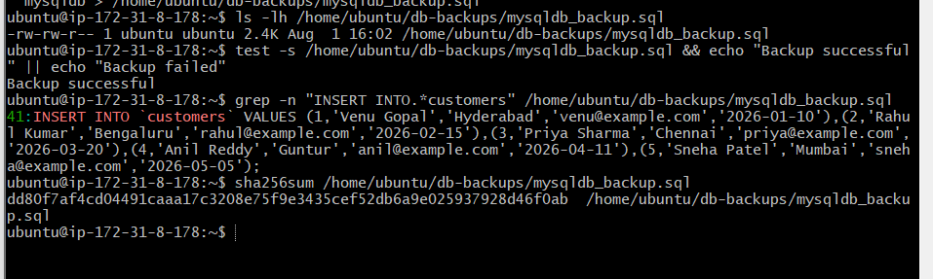

Restore the backup to MySQL RDS
Run these commands on MySQL-EC2-Server.
Step 5: Copy the MySQL RDS endpoint
Open:
RDS → Databases → mysql-rds-instance
→ Connectivity & security
Copy the Endpoint, then set it on EC2:
MYSQL_RDS_ENDPOINT="paste-mysql-rds-endpoint-here"
Example format:
MYSQL_RDS_ENDPOINT="mysql-rds-instance.xxxxxxxxxxxx.us-east-1.rds.amazonaws.com"
Verify:
echo "$MYSQL_RDS_ENDPOINT"
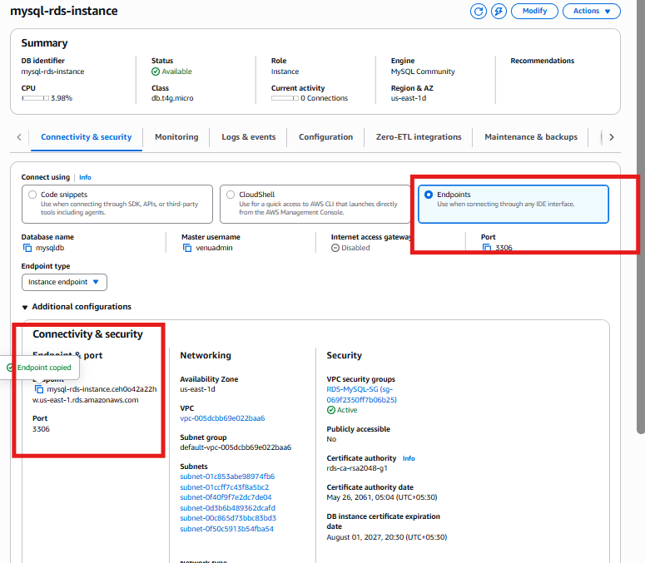
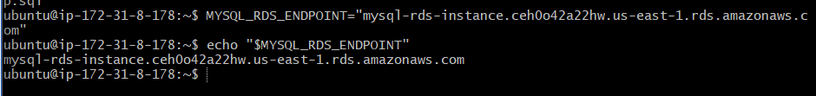
Step 6: Test connectivity
getent hosts "$MYSQL_RDS_ENDPOINT"
Test port 3306:
timeout 5 bash -c "</dev/tcp/$MYSQL_RDS_ENDPOINT/3306" && echo "Port 3306 reachable" || echo "Port 3306 blocked"
Expected:
Port 3306 reachable
Step 7: Download the RDS certificate
curl -o global-bundle.pem https://truststore.pki.rds.amazonaws.com/global/global-bundle.pem
Verify:
ls -lh global-bundle.pem
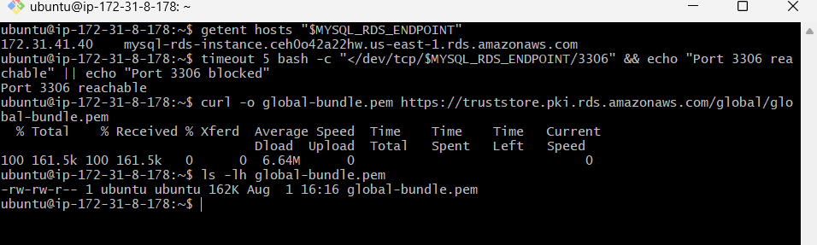
Step 8: Test the RDS login
mysql \
-h "$MYSQL_RDS_ENDPOINT" \
-P 3306 \
-u venuadmin \
-p \
--ssl-mode=VERIFY_IDENTITY \
--ssl-ca=global-bundle.pem
Enter the MySQL RDS master password.
Run:
SELECT VERSION();
SHOW DATABASES;
Confirm that this database exists:
mysqldb
Exit:
EXIT;
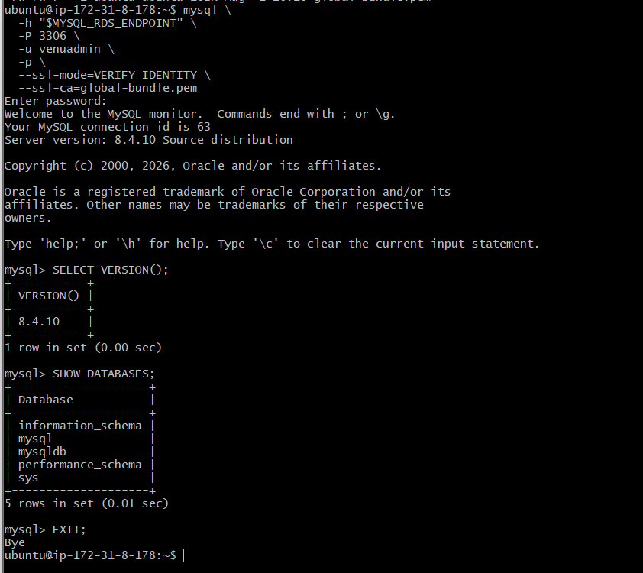
Step 9: Restore the backup
At the Ubuntu $ prompt:
mysql \
-h "$MYSQL_RDS_ENDPOINT" \
-P 3306 \
-u venuadmin \
-p \
--ssl-mode=VERIFY_IDENTITY \
--ssl-ca=global-bundle.pem \
mysqldb < /home/ubuntu/db-backups/mysqldb_backup.sql
Enter the RDS master password. Returning to the Ubuntu prompt without an error normally means the restore succeeded.
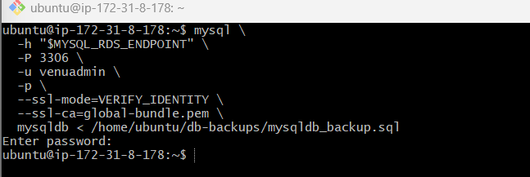
Step 10: Verify the restored data
Connect again:
mysql \
-h "$MYSQL_RDS_ENDPOINT" \
-P 3306 \
-u venuadmin \
-p \
--ssl-mode=VERIFY_IDENTITY \
--ssl-ca=global-bundle.pem
Run:
USE mysqldb;
SHOW TABLES;
SELECT * FROM customers;
SELECT COUNT(*) AS restored_rows FROM customers;
Expected:
customers
restored_rows: 5
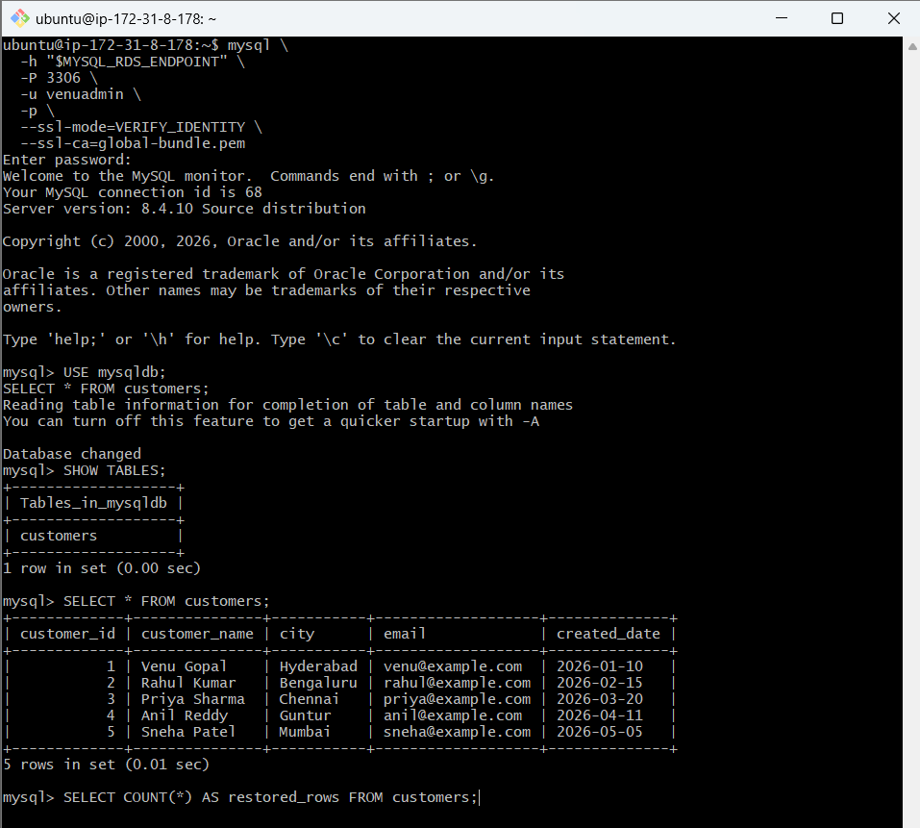
Task 10: Create a MySQL read replica
A read replica creates another chargeable RDS instance and uses asynchronous replication. It is used for read scaling and reporting, not automatic failover.
Step 1: Start read-replica creation
Open:
Aurora and RDS → Databases
Select:
mysql-rds-instance
Then click:
Actions → Create read replica
If Create read replica is selectable, click it.
Step 2: Configure basic settings
Setting | Value
Source | mysql-rds-instance
Replica identifier | mysql-read-replica
Instance class | db.t4g.micro
Destination Region | US East (N. Virginia)
Storage
Setting | Value
Storage type | General Purpose SSD (gp2)
Allocated storage | 20 GiB
Storage autoscaling | Disabled
Storage configuration upgrade | Latest/current configuration
Availability
Select:
Single-AZ DB instance deployment (1 instance)
Do not choose either Multi-AZ option. A Multi-AZ read replica would create additional standby instances and substantially increase cost.
Connectivity
Setting | Value
Network type | IPv4
DB subnet group | default-vpc-005dcbb69e022baa6
Public access | Not publicly accessible
Security group | RDS-MySQL-SG
Availability Zone | No preference
Certificate authority | rds-ca-rsa2048-g1
Authentication
Select:
Password authentication
The read replica uses credentials copied from its source database. You do not create another master password here.
Tags
Optional:
Key: Name
Value: MySQL-Read-Replica
Monitoring — change required
Your summary currently says:
Enhanced Monitoring turned on
Uncheck:
Enable Enhanced Monitoring
Select:
Database Insights – Standard
Leave all log exports unchecked:
Audit log
Error log
General log
IAM DB authentication error log
Slow query log
After disabling Enhanced Monitoring, the 60 seconds and monitoring-role fields should disappear or become inactive.
Encryption
Keep encryption enabled. Do not change the inherited KMS ARN:
arn:aws:kms:us-east-1:800380167135:key/7ff81f4d-1122-47ae-9bb1-97797fe25c38
An encrypted source requires an encrypted read replica.
Maintenance and deletion
Setting | Selection
Auto minor version upgrade | Enabled
Deletion protection | Disabled
Copy tags to snapshots | Optional
Final checklist
Before creation, confirm:
Single-AZ
Not publicly accessible
RDS-MySQL-SG
Password authentication
Database Insights Standard
Enhanced Monitoring off
Encryption on
Deletion protection off
Review the estimated cost, then click Create read replica.
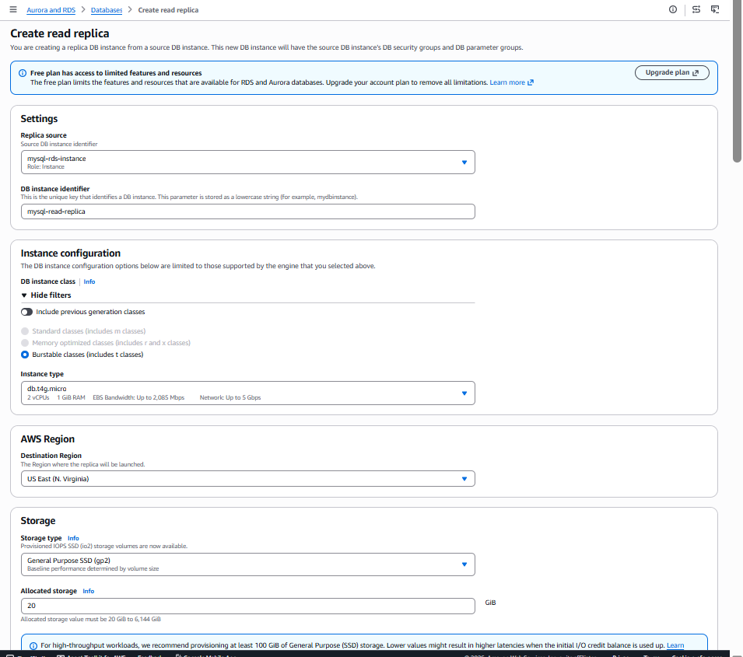
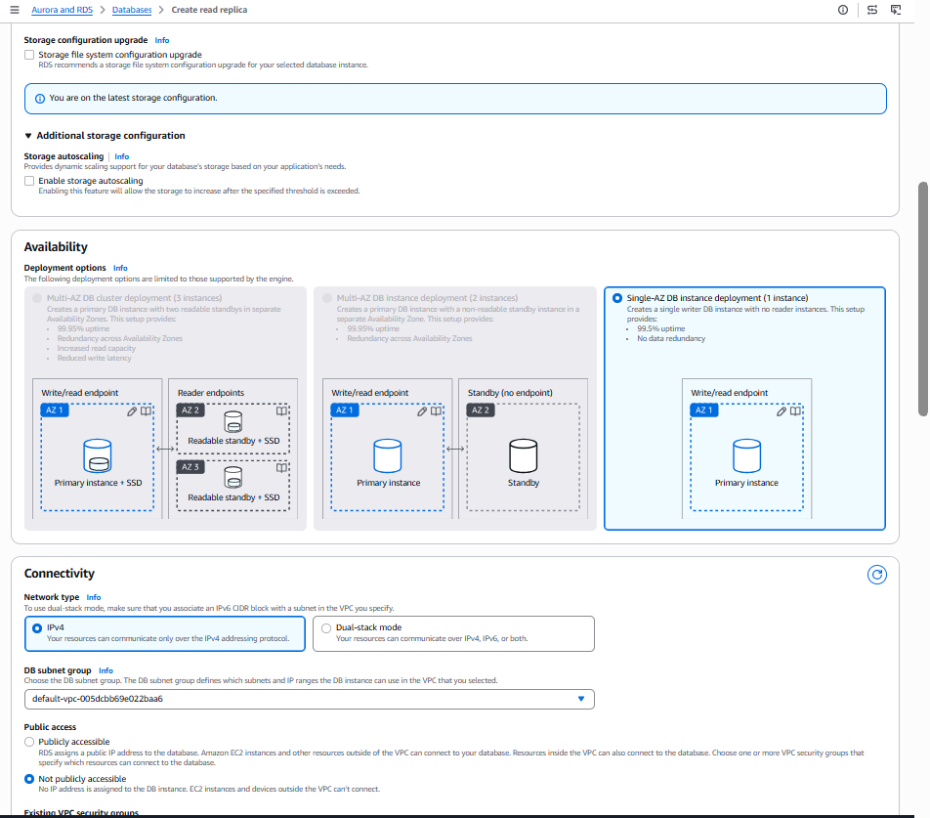
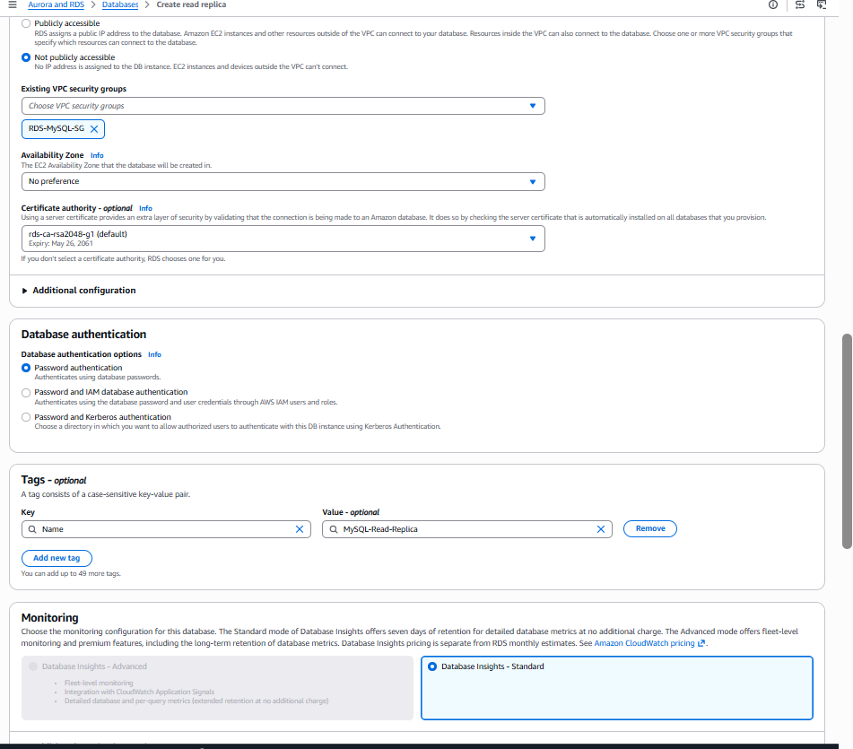
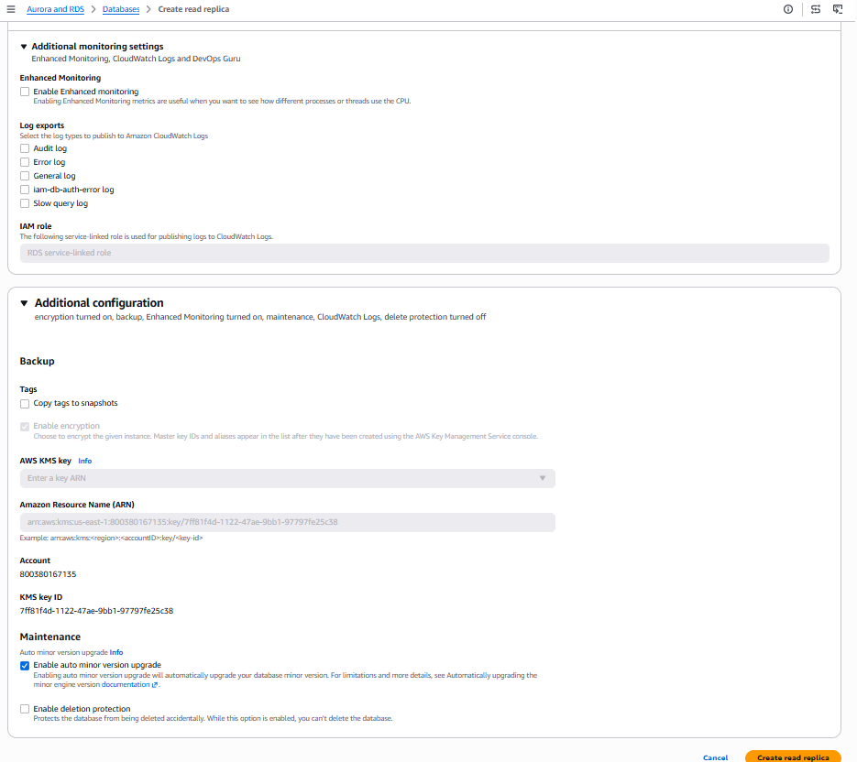
Verify the MySQL read replica
Step 1: Wait for availability
Refresh the RDS Databases page until both show:
mysql-rds-instance → Available
mysql-read-replica → Available
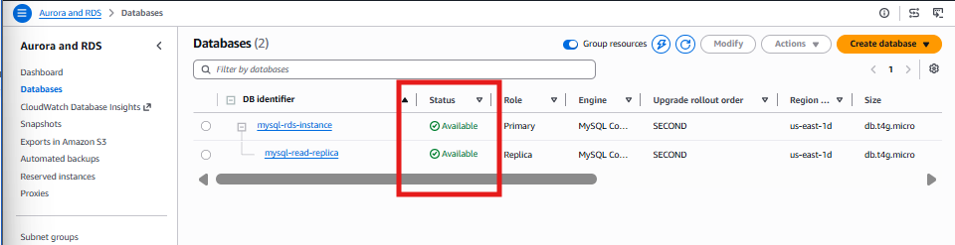
Step 2: Copy the replica endpoint
Open:
RDS → Databases → mysql-read-replica
→ Connectivity & security
Copy the Instance endpoint.
It will resemble:
mysql-read-replica.xxxxxxxxxxxx.us-east-1.rds.amazonaws.com
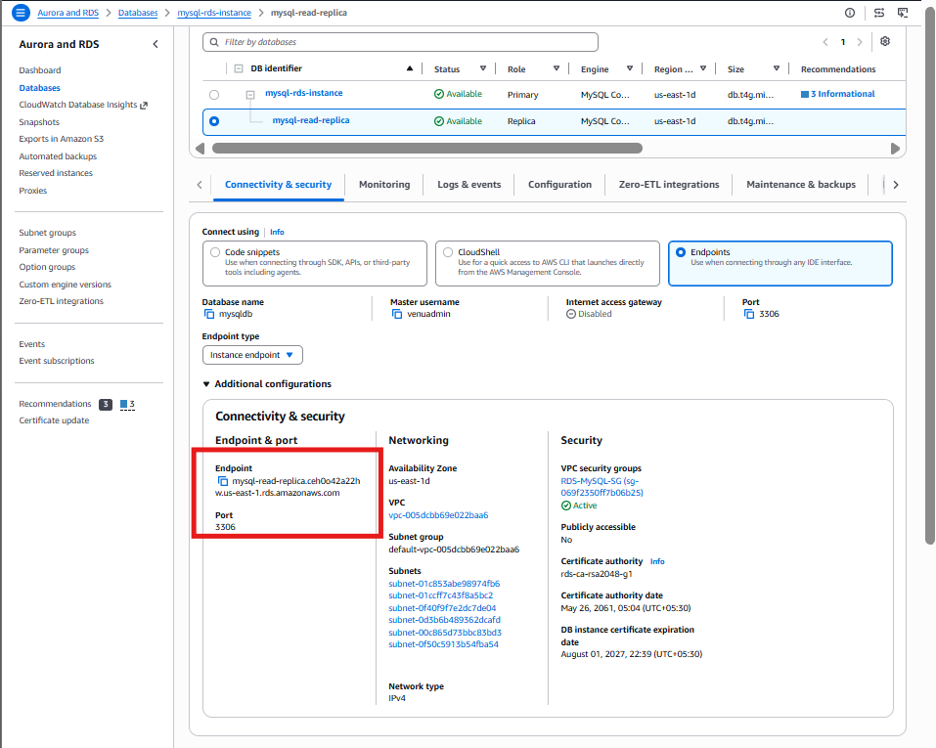
Step 3: Connect to MySQL EC2
Connect to MySQL-EC2-Server using Git Bash:
ssh -i "MariaDB-Key.pem" ubuntu@MYSQL-EC2-PUBLIC-DNS
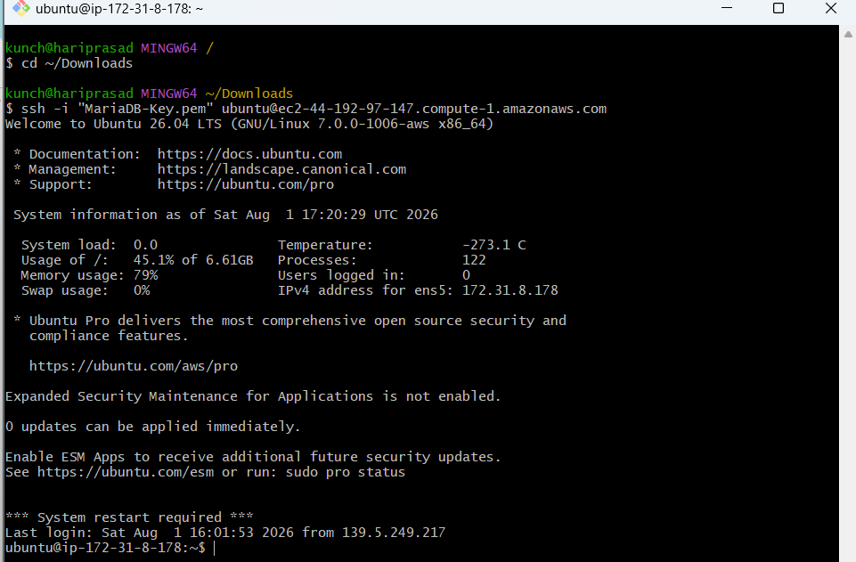
Step 4: Set the replica endpoint
On MySQL EC2:
REPLICA_ENDPOINT="paste-read-replica-endpoint-here"
Verify:
echo "$REPLICA_ENDPOINT"
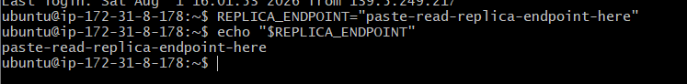
Step 5: Connect to the read replica
The RDS certificate should already exist on MySQL EC2. Verify:
ls -lh global-bundle.pem
Connect:
mysql \
-h "$REPLICA_ENDPOINT" \
-P 3306 \
-u venuadmin \
-p \
--ssl-mode=VERIFY_IDENTITY \
--ssl-ca=global-bundle.pem
Use the same RDS password as the primary instance.
Step 6: Verify the replicated records
At the mysql> prompt:
USE mysqldb;
SHOW TABLES;
SELECT * FROM customers;
SELECT COUNT(*) AS replicated_rows FROM customers;
Expected:
customers
replicated_rows: 5
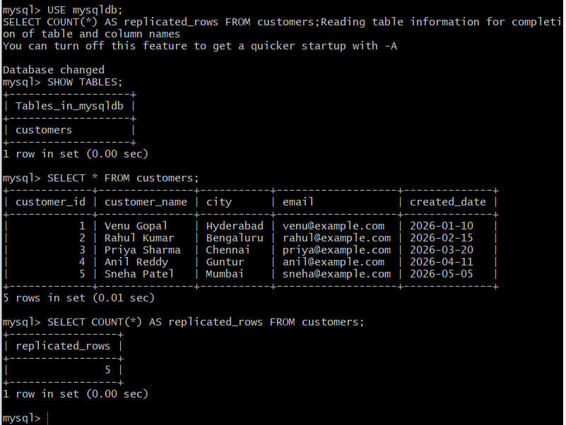
Step 7: Confirm read-only mode
SELECT @@hostname AS server, @@read_only AS read_only, @@super_read_only AS super_read_only;
Expected:
read_only: 1
super_read_only: 1
This confirms you connected to the read replica rather than the primary.
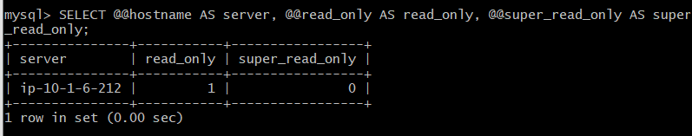
Step 8: Check replication status
SHOW REPLICA STATUS\G
Look for values similar to:
Replica_IO_Running: Yes
Replica_SQL_Running: Yes
Seconds_Behind_Source: 0
You can also verify replica lag from:
RDS → mysql-read-replica → Monitoring → ReplicaLag
